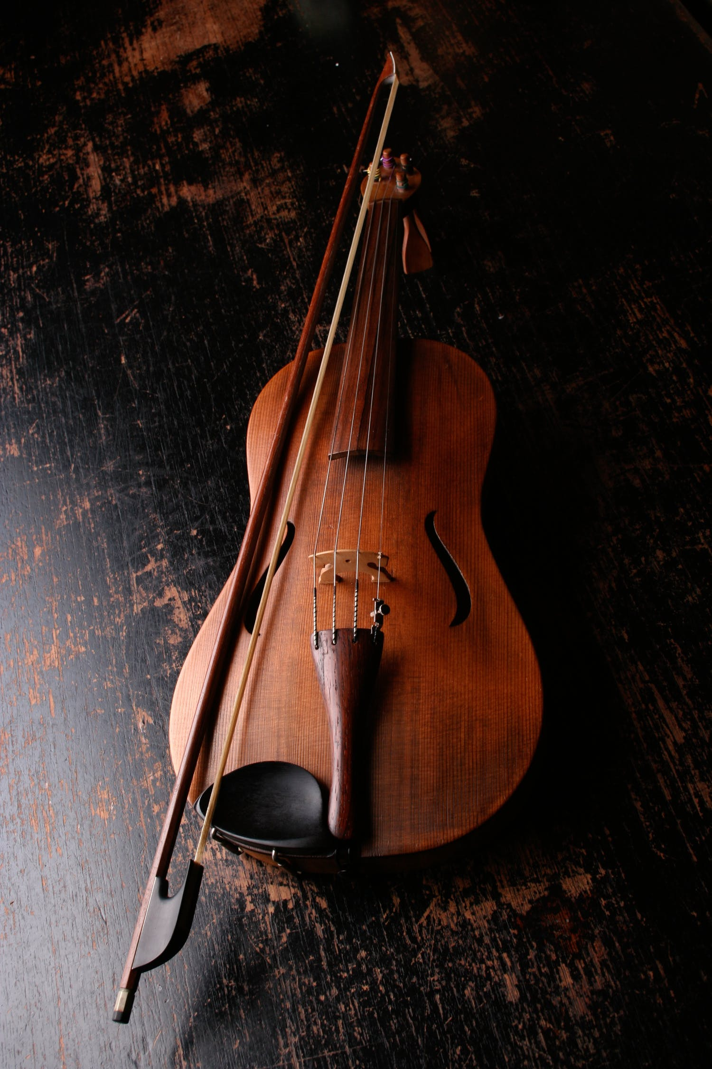

**ORCHESTRAL CONCERT** Beethoven’s 250th Anniversary conducted by Nigel Morley

St Mary’s Church, Frampton

Saturday 28th March 7.30pm

Leonora Overture No 1

Two Romances for Violin and Orchestra ***Soloist***[***Anne Dales***](https://www.bostonsinfonia.org.uk/page_1611802.html)

Egmont Overture

Symphony No 7

Tickets £10 from the Stump Gift Shop

online at www.bostonsinfonia.org.uk

and £12 on the door; under 18s free