Macintosh HD:Users:David:Documents:Boston Sinfonia:Sinfonia Logos:New Logo.wmf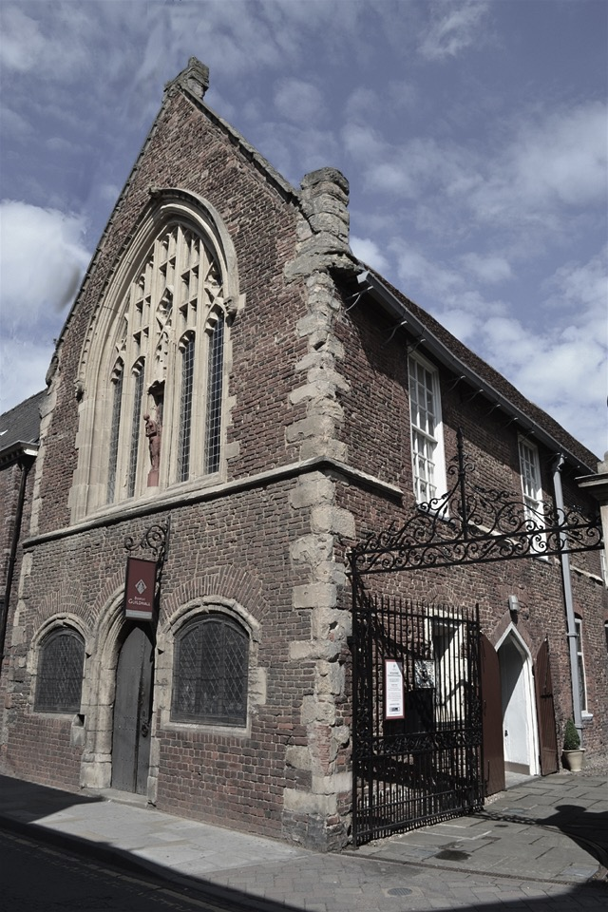

**Boston Guildhall Sunday 26th November**

**at 3.00pm**

***Rossini - Overture II Signor Bruschino***

***Mozart - Bassoon Concerto***

***Soloist - Simon Vickers***

***Haydn - Symphony No 83 “La Poule”***

Tickets £10 from Stump Gift Shop (10-3.30 Mon-Sat)

online at www.bostonsinfonia.org.uk

and £12 on the door; under 18s free

(it is advised to book early due to limited seating)