Description: Macintosh HD:Users:David:Documents:Boston Sinfonia:Sinfonia Logos:New Logo.wmf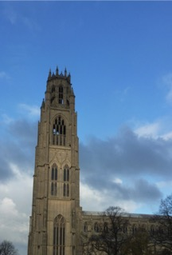

**St Botolph’s Church “Boston Stump”**

**Saturday 9th June 7.30pm**

***Rimsky-Korsakov - Tsar’s Bride Overture***

***Shostakovich - Piano Concerto No 2***

***Soloist Christopher Atkinson***

***Tchaikovsky - Symphony No 5***

Tickets £10 from Stump Gift Shop

online at www.bostonsinfonia.org.uk

and £12 on the door; under 18s free